Carl “Coral” Watts
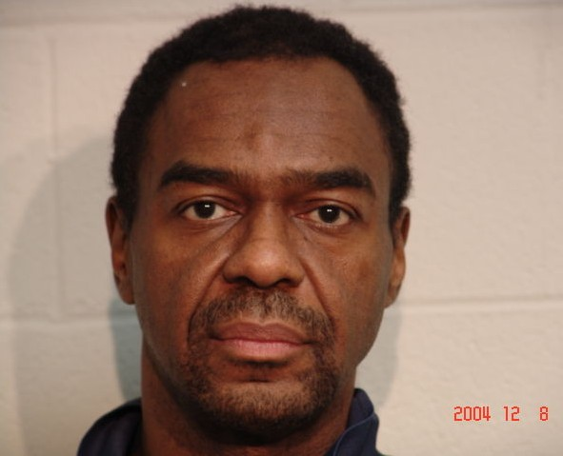

General

Gender | Male
Race | African American
Country | America
Sexual Orientation | Heterosexual
Highest Level of Academic Achievement (degree attained) | High school.
Drop-Out | Yes, College
GED (high school equivalency) | No
Diagnosis | - Mild mental retardation  - Depression  - Anti-social personality disorder

Guardian Variables
Guardian Other Than biological/adoptive parent (i.e. aunt, grandmother, etc.) | Yes. Grandmother
Parents Marital Status | Divorced
Spousal Abandonment | Mother and child relocated apart from father.
Domestic Abuse | No
Abuser | N/A
Maternal Mental Illnesses | No
Paternal Mental Illnesses | No
Socioeconomic Status | Low-middle class, worker

Childhood Variables
Birth Order | First of three. Two later daughters from his mother’s remarriage.
Child living with | Mother
Child Abuse | No
Type of Abuse | N/A
Abuse Perpetrators | N/A
Head Injuries | No
MacDonald Triad | No

Adolescent Variables
Juvenile Record | Yes
Convicted Offences | Assault (violent behavior) at age 15.
Non-Convicted Crimes | Unknown
Sexual/violent fantasy development? | Yes. Age at Development: 12
Fantasy Specifics | Watts claimed to have started to fantasize about torturing and killing girls and young women.
Fetish (i.e. underwear) | No
Adult Variables
Significant Others | Wife
Married | Yes
Multiple Divorces | One divorce in 1980.
Occupation | Diesel mechanic
Criminal Record | Yes
Criminal Versatility | No Specifics: Violent behaviour, Sexual assault, Break and entry, Murder
Substance Abuse | Yes

Murder Information
Decade that murders occurred | 1970-80s
Age at beginning of series | 20
Stressor | n/a
Victimology | Sex: Female Age Range: 14-44 Race: White Additional: n/a
Number of Victims | 22-100+
Method of Killing | Strangulation, stabbing, bludgeoning, drowning
Rape | No
Necrophilia | No
Serial Killer Typology | Disorganized; Mission-oriented
Token | No
Partner | No
Method(s) used to evade law enforcement | Frequently relocated between several states and jurisdictions.

Media Coverage of Capture

Link 1

Link 2

Link 3

Link 4

Police Interview

Police Interview (PDF)

Police Interview (Video)

Trial Proceedings

Trial Proceedings (PDF)

Trial Proceedings (Video)

Psychological Assessment

Psychological Assessment (PDF)

Documentary Films

Title: | Coral Eugene Watts; Sunday Morning Slasher https://www.youtube.com/watch?v=gA3f99wcREk
Title: | Serial Killer Coral Eugene Watts https://www.youtube.com/watch?v=sP8oYNM1keo

Death
Information on Death | Died of prostate cancer while in jail.

References | - Mitchell, C. (2006). Evil Eyes: The Most Insatiable Serial Killer Ever. New York, NY: Kensington Publishing Corp.  - Murderpedia. Retrieved from: http://murderpedia.org/male.W/w/watts-carl-eugene.htm

